EXTENDED ABSTRACTS

Modeling and Static Analysis of Two-Dimensional Linear Trusses Using Graphic Static Method

Farnaz Abazari Esfahlan, Taha Sabaghian, Yaser Shahbazi *

Architecture and Urbanism Department, Tabriz Islamic Art University, Tabriz, Iran

Received: 01 December 2021; Review: 24 February 2022; Accepted: 17 March 2022

Keywords:
Truss, Parametric, Graphic static, Python, Grasshopper.

1. Introduction
Graphic statics is a geometric method for analyzing and calculating the internal forces in each member of a structure generated under external loads. In this method, the relationship between form and internal forces in the members can be seen geometrically, and in addition, the amount and type of these forces in terms of traction, pressure and zero force, are determined graphically. The process of parametrization of this method in two parts of form production and calculation of internal forces, including important cases to obtain various designs with strength, stability and load bearing in the shortest time has been caused. This process has created the conditions to choose the best geometric topology from the numerous options available based on criteria and goals with parameters related to the structure such as external loads. The graphic statics method was formed after Stevin's theory of the law of equilibrium of forces in closed polygons (Stevin, 1586). Varignon developed this theory by stating that lines parallel to forces can be drawn to calculate the result of forces, and that as long as the result of the vectors creates a closed environment, there is an equilibrium of forces together (Varignon, 1725). According to this proposition, in each node of a structure under the influence of different forces, there is a closed force polygon that corresponds to the static equilibrium. Two-dimensional diagrams of form and force were thus defined by Maxwell in 1864, which distinguished a landmark in the description of the method of static graphic analysis (McRobie et al., 2017). In defining graphic statics drawing methods, form and force diagrams, two types of pole point method and Bow’s notation methods are considered. The pole point method is used for integrated structures such as vault and dome structures and the Bow’s notation is suitable for structures with fragmented sides such as trusses (Wolfe, 1921). In Fig. 1. Drawing of force diagram by the Bow’s notation was illustrated.

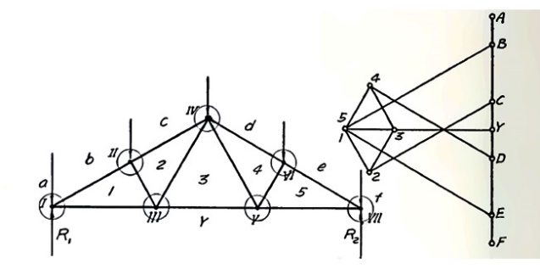
Fig. 1. Drawing of force diagram by the Bow’s notation in the right from form diagram in the left (Wolfe, 1921)
2. Methodology
In this article, various truss designs, taken from the famous models of Warren, Pratt, Howe and Fink, are graphically and structurally analyzed. During the problem-solving process with the help of Graphic statics, a parametric relationship is obtained between the geometric form of the truss and the amount of internal force of the members and in the continuation of the process, by changing the truss forms and converting the standard and linear types, free forms are created and categorized. The various parts of research are parametrically coded in Rhinoceros 6 software and Grasshopper plug-in. Since, Python programming language has been used, the speed of calculations was increased and designing became more easer. The process of drawing graphic diagrams in the algorithm can be defined in three general steps. In the first step, the initial form of the considered truss is produced parametrically, and in each stage, it is possible to add or remove a member without the need for redrawing. This method has been implemented for Warren, Howe, Pratt and Fink trusses. Next, the forces acting on the truss nodes are determined and the moment of the forces is calculated. The calculations of this step, due to being parametric, its values can be changed and updated in each step. Finally in this algorithm, it is possible to draw a graphic statics force diagram based on the generated truss. This step is done according to the Bow’s notation method and parallel drawings. In this part, according to the clockwise calling of the notations and following the path of drawing the lines in the force diagram, the type of internal stress of the members can be identified. The efficiency of the present method is shown through several examples for different types of trusses, both in standard and free form, and the results are compared with calculated samples. In Fig. 2. Graphically, the process of the coded algorithm is illustrated.

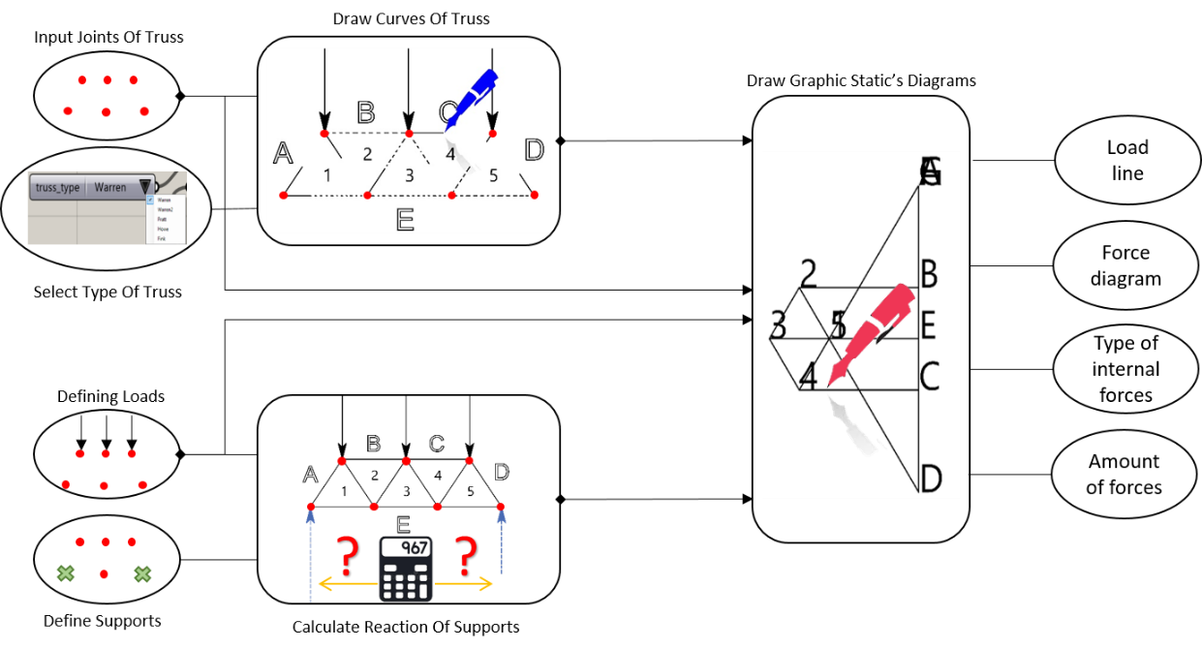
Fig. 2. Graphical representation of graphic statics algorithm for truss analysis

3. Results and discussions
In this article, the static analysis of the truss is investigated by the graphic statics method and compared with a sample that has already been calculated was presented in Fig. 3. Comparison of the results of the computational method and the graphical method shows that all methods are sufficiently accurate and have a small percentage of deviation from each other. For this purpose, the correctness of static analysis of a model of Warren truss is verified. In Table 1. Comparison of validation results it is significant. The obtained numbers, regardless of the tension or compressive loads in each element, are all recorded in a positive state, and by comparing the absolute value of the numbers relative to each other, it is observed that the obtained results have a small error percentage from the numerical calculation method. Then coded algorithm gives the correct results in the graphic statics method. Respectively, Positive and negative numbers in numerical calculations represent tension and compressive members that are shown with (T) and (C) letters. In the meantime, if there are zero force members, it is the Neutral member, which is identified by the abbreviation (N). Based on the determination of tension and compressive of internal loads in the Bow’s notation method, the type of internal elements stress was correctly detected by the algorithm.
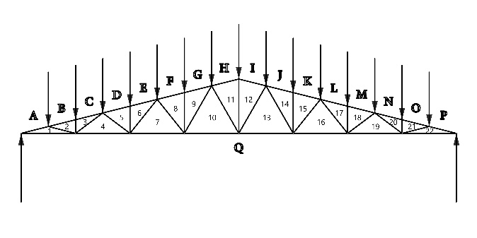 | 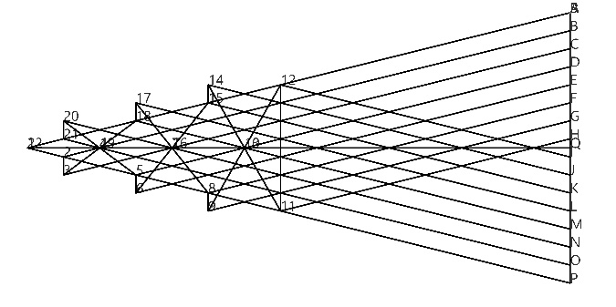
Fig. 3. Selected Warren truss type for comparing amount of forces among graphic statics and numerical methods

Table 1. Comparison of validation results which in distinguished column calculated numeric method are compared with the right-side amount that made by authors (Bocko and Lengvarsky, 2016)
Internal tensions | Axial force [KN] | Stress [MPa] | Axial force [KN] | Nr.
T | 60 | 31.25 | 60 | 1=43
C | 61.846584 | -32.21 | -61.85 | 2=44
C | 4.123106 | -7.25 | -4.12 | 3=45
C | 57.723479 | -30.06 | -57.72 | 4=42
C | 57.723479 | -30.06 | -57.72 | 5=39
C | 2 | -3.62 | -2.06 | 6=41
T | 5 | 8.9 | 5.09 | 7=40
T | 52 | 27.05 | 51.93 | 8=38
C | 49.477268 | -25.77 | -49.48 | 9=36
C | 5 | -8.9 | -5.09 | 10=37
C | 49.477268 | -25.77 | -49.48 | 11=33
C | 2 | -3.62 | -2.06 | 12=35
T | 6.403124 | 11.25 | 6.4 | 13=34
T | 44 | 22.92 | 44.01 | 14=32
C | 41.231056 | -21.47 | -41.22 | 15=30
C | 6.403124 | -11.25 | -6.4 | 16=31
C | 41.231056 | -21.47 | -41.22 | 17=27
C | 2 | -3.62 | -2.06 | 18=29
T | 8.062258 | 14.17 | 8.06 | 19=28
T | 36 | 18.75 | 36 | 20=26
C | 32.984845 | -17.18 | -32.99 | 21=23
C | 8.062258 | -14.17 | -8.06 | 22=25
T | 14 | 24.6 | 14 | 24

4. Conclusions
According to the solved examples, it is clear that each set of introduced and parametric trusses has the ability to become countless free form modes with various complexities. After validating the coded method and algorithm, it can be stated that the graphic statics method shows a good performance in calculating the internal force of the sides in standard and free form trusses. Also, in the study of tension and compressive element, the coded algorithm based on the graphic statics method, recognizes the type of force in each element with high accuracy. Making parametric format of the method has resulted in the creation of various samples of trusses along with their static analysis in the shortest time, which in total, increases the strength and speed of design based on load bearing in trusses.
In the following, some examples trusses are examined and analyzed by graphic statics method. In the pictures of Table 2. A magnified example of the form diagram of different trusses and the related force diagram is shown, in which the force and stress characteristics of each side are calculated and written by the algorithm. In this specification, the first line represents the member’s name, the second line represents the internal stress of the components, and the third line represents the internal force of the members in Newtons. It should be noted that the internal stresses of the elements are marked with Compression, Tension and the neutral.

Table 2. Exemplary truss form and force diagrams with information extracted from graphic statics algorithm
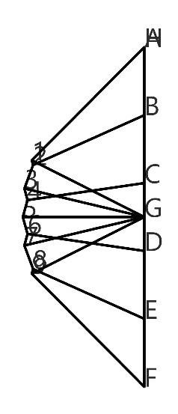 | 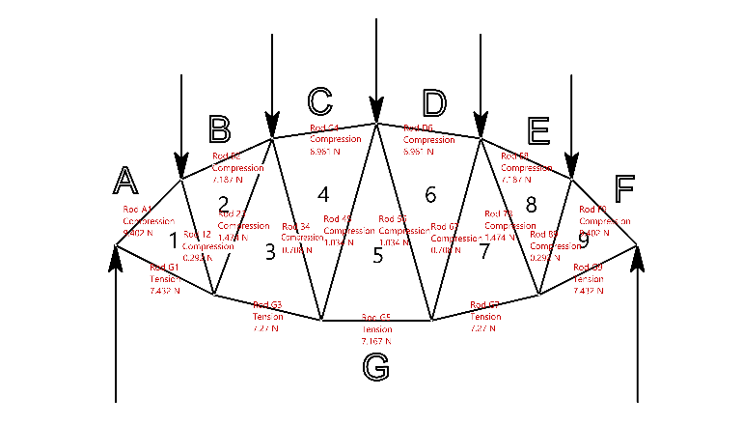
Warren Arc Truss Force Diagram | Warren Arc Truss Form Diagram
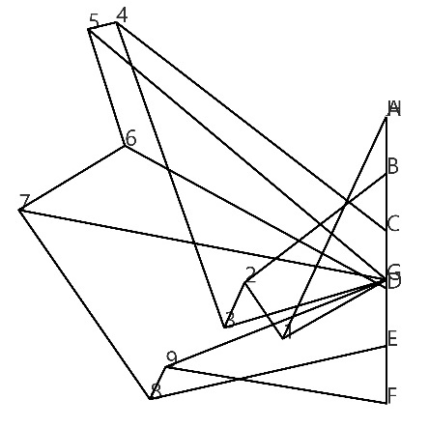 | 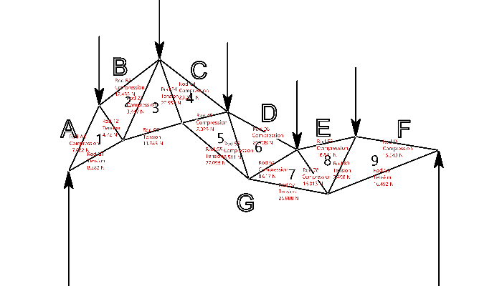
Warren Free-Form Truss Force Diagram | Warren Free-Form Truss Form Diagram
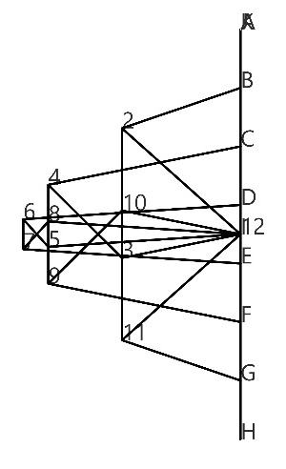 | 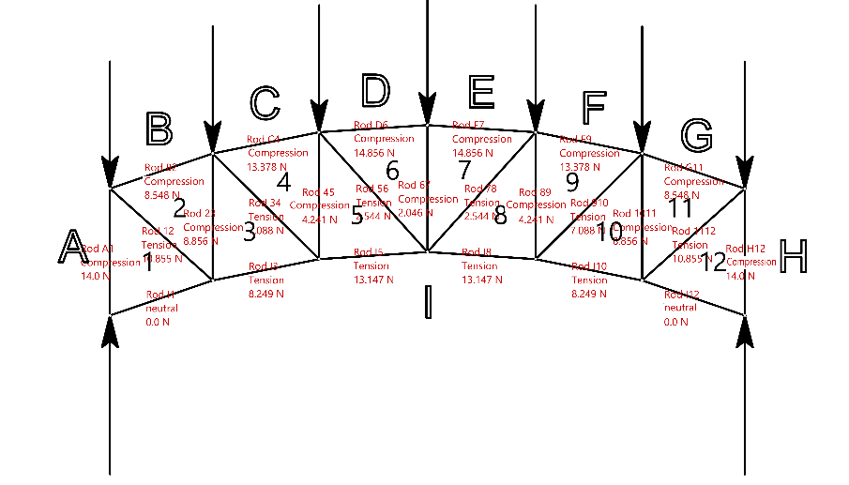
Pratt Arc Truss Force Diagram | Pratt Arc Truss Form Diagram
 | 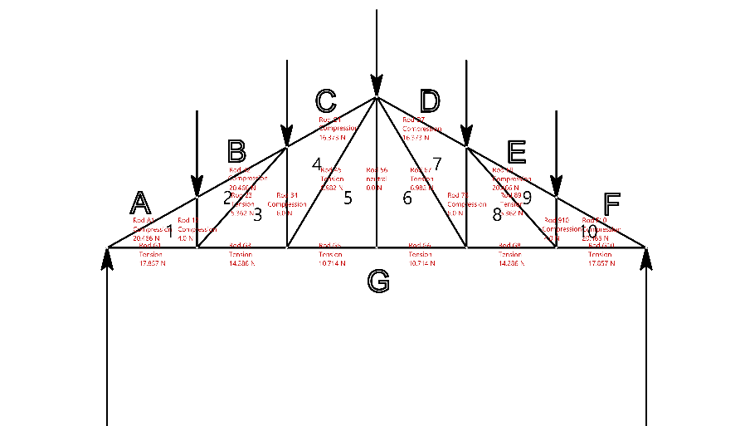
Sloping Howe Truss Force Diagram | Sloping Howe Truss Form Diagram
5. References
Lengvarsky P, Bocko J, “The static analysis of the truss”, American Journal of Mechanical Engineering, 2016, 4 (7), 440-444.
McNeel R, Others, “Rhinoceros 3D, Version 6.0”, Robert McNeel & amp, Associates, Seattle, WA, 2010.
McRobie A, Konstantatou M, Athanasopoulos G, Hannigan L, “Graphic kinematics, visual virtual work and elastographics”, Royal Society Open Science, 2017, 4 (5), 170202. https://doi.org/10.1098/rsos.170202
Rutten D, others, “Grasshopper 3D, Version 14.0”, Robert McNeel & amp, Associates, WA, 2020.
Stevin S, “In the Principal Works of Simon Stevin: General introduction mechanics”, Swets and Seitlinger, 1955.
Van Rossum G, “Python, Version 2.7”, Centrum voor Wiskunde en Informatica (CWI), Amsterdam, 2010.
Varignon P, “Nouvelle mécanique ou statique”, Paris, 1725. Nouvelle mécanique, ou, Statique, dont le projet fut donné en M. DC. LXXXVII: Varignon, Pierre, 1654-1722: Free Download, Borrow, and Streaming: Internet Archive
Wolfe W, “Graphical analysis”, McGraw-Hill Book Co. Inc., New York, 1921. Graphical analysis; a text book on graphic statics: Wolfe, William Sidney, b. 1889: Free Download, Borrow, and Streaming: Internet Archive

