EXTENDED ABSTRACTS

Investigating the effect of saturated sand layer thickness on the performance of deep soil mixing columns and gravel columns in reducing risks caused by liquefaction

Gholi Asadzadeh Khoshemehr ª, Hadi Bahadori ^{b,*}

ª Ph.D. Candidate, Faculty of Civil Engineering, University of Urmia, Urmia, Iran
^{b} Professor, Faculty of Civil Engineering, University of Urmia, Urmia, Iran

Received: ………………..; Accepted: …………………..

Keywords:
Deep Soil Mixing, Gravel Drain Fatigue, The thickness of liquefiable layer, Frequency, Average shear modulus.

1. Introduction
In the present paper, the results of a series of seismic experiments in a 1g environment on a structure located over liquefiable ground with different thicknesses reinforced with GD and DSM techniques were presented. The dynamic response of the reinforced ground system was investigated based on the parameters of settlement, excess pore water pressure ratio, maximum acceleration, behavior of stress-strain of reinforced soil. The time history of the input acceleration was applied harmonically with an acceleration range of 0.2g and at frequencies of 1, 2, and 3 Hz. results of experimental investigations show that the thickness of the liquefiable layer and the frequency of the input motion have a significant impact on the effectiveness of the improvement method and all responses.

2. Methodology
2.1. Experimental study
In this study, 10 experiments (one non-improved land model and nine improved land models) were performed by utilizing of shaking table and laminar shear box. The details of the experiment are shown in Table 1. In these experiments, the effect of liquefiable soil layer thickness on the performance of two improvement methods (GD and DSM columns) was investigated.

Table 1. Details of performed tests
Thickness of layers |  | Loading frequency (HZ) | DSM & GD |  | Test series | Test NO.: | Number of tests
h2 | h1 |  | Length(cm) | Diameter(cm)
5 | 65 | 2 | No | No | … | A | 1
5 | 65 | 1 | 65 | 5 | D5 | D5F1 | 2
5 | 65 | 2 | 65 |  |  | D5F2 | 3
5 | 65 | 3 | 65 |  |  | D5F3 | 4
30 | 40 | 1 | 40 |  | D30 | D30F1 | 5
30 | 40 | 2 | 40 |  |  | D30F2 | 6
30 | 40 | 3 | 40 |  |  | D30F3 | 7
50 | 20 | 1 | 20 |  | D50 | D50F1 | 8
50 | 20 | 2 | 20 |  |  | D50F2 | 9
50 | 20 | 3 | 20 |  |  | D50F3 | 10
The relative density of the loose layer is equal to 25% and the relative density of the dense layer is equal to 80%.
2.2. modeling
Figure 1 shows the box in plan. Both improvement techniques were placed in one model to simultaneously evaluate the effectiveness of the improvement methods in the same conditions. It is noteworthy that the two foundations were placed at a suitable distance from one another to eliminate the effects of interaction. According to (Lou et al., 2011), if the distance between two similar structures is more than 2.5 times the width of the foundation, the interaction effects can be neglected, and if the distance between two structures is less than the width of the foundation, the response of the structure due to interaction is about a 10% increase or decrease. In engineering projects, the diameter of GD and DSM columns is usually designed and executed between 0.5 to 1.50 meters. Furthermore, based on the site and the subsurface layers, the length-to-diameter ratio is 6 to 20. The area replacement ratio is applied between 5% and 30%, which primarily depends on the layer thickness and the degree of relative density (Yang et al., 2021). The geometry of the GD and DSM columns is similar in the model. In the prepared model, the arrangement of the columns is triangular, there are eight of them on each side, and their diameter is 5 cm. The area replacement ratio (Ar) is equal to 18.2% . The dimensions of the foundations are 22 cm in width, 30 cm in length, and 6 cm in thickness, with a weight of 30 kg. The foundation used represents a building of about 10 floors with a stress of 90.91 kPa beneath the foundation. The model consists of two layers: a layer of dense sandy soil at the bottom and a layer of loose sand at the top.

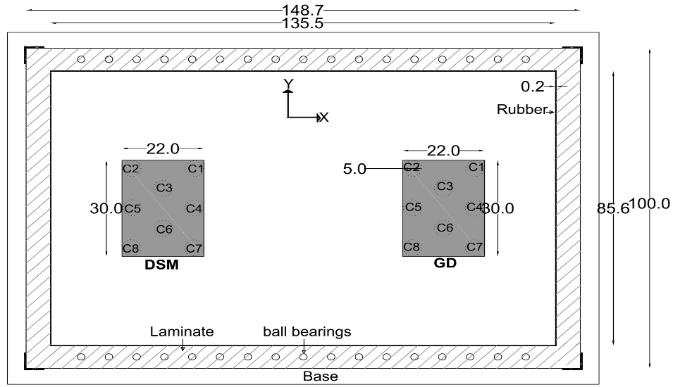
Fig. 1. Model plan (dimensions in centimeters)

3. Results and discussion
3.1. Effect of thickness of liquefiable layer on the excess pore water pressure
The thickness of the liquefiable layer and the frequency of the input motion have important effects on the maximum values of the ru. The rumax values in the unimproved ground (Test A) were higher than in other cases, and complete liquefaction occurred. However, in other tests, due to soil improvement under the foundation, soil behavior and responses changed significantly, and the value of the excess water pressure ratio was generally reduced.

3.2. Effect of input frequency on the settlements
The dominant frequencies in the D5 test series at the beginning and end of the test were estimated to be 14 Hz and 1.45 Hz, respectively. In other words, the dominant frequency of the system is decreased due to pore water pressure buildup. The amount of input frequency in the soil system and foundation at different thicknesses in liquefiable soil has diverse effects on the subsidence behavior of the foundation. The maximum settlement values ​​at different thicknesses of the liquefiable soil layer are related to its input frequency. In GD columns in the D5 test series, where the thickness of the liquefaction layer was high, the maximum settlement value was much higher at 1 Hz compared with higher frequencies. Also, in the D30 series tests, where the thickness of the liquefiable layer was 40 cm, the amount of subsidence at 2 Hz was higher than at other frequencies. In the D50 series tests, where the thickness of the liquefiable layer was low, the subsidence at a frequency of about 3 Hz was more than at other frequencies. This general trend could be attributed to the reality that in thick liquifiable layer the dominant frequency is lower and so in low input frequencies the resonance phenomenon causes larger settlements.
3.3. Behavior of stress-strain
According to the hysteresis curves in test A, it can be seen that the stress and strain loops tend to become horizontal in the first cycles of loading, which indicates the decrease in soil hardness, which is caused by the liquefaction phenomenon in the soil layer. But in other models, due to the use of improvement methods in the soil, the tendency of the stress and strain rings to become horizontal decreases, and more cycles are required for the rings to become horizontal.

4. Conclusions
The main purpose of this paper is to investigate the effect of liquefiable layer thickness on the dynamic behavior of the foundation placed on a saturated loose sand layer that has been improved by two techniques of deep mixing columns (DSM) and gravel drain columns (GD). Acceleration peak and input frequency affect the acceleration response at ground level. The ratio of the input acceleration peak to the horizontal acceleration peak at the foundation level in the non-improved model (Test A) was less than unity, while in the improved ground, this ratio was more than unity. Deep mixing columns have significantly magnified ground surface accelerations compared with gravel drain columns, indicating that the ground is reinforced with deep mixing columns. As the thickness of the saturated loose layer decreases, the effect and dynamic behavior of the gravel columns become closer to the deep mixing columns. Therefore, in variable thickness layers, time and cost can be saved by choosing the optimal improvement method. In thick, loose, saturated sand layers, due to the production of high pore water overpressure and large shear strain, the hardness values of the soil mass drop sharply. Among the two improvement methods mentioned, the new technique of deep mixing columns in thick layers has a better performance than sand columns and has significantly maintained the average shear stiffness and reduced the shear strain of the soil mass.

5. References
Lou M, Wang H, Chen X, Zhai Y, “Structure–soil–structure interaction: Literature review”, Soil Dynamics and Earthquake Engineering, 2011, 31(12), pp. 1724-1731.
Yang F. O, Fan G, Wang, K, Yang C, Lyu W, Zhang J, “A large-scale shaking table model test for acceleration and deformation response of geosynthetic encased stone column composite ground”, Geotextiles and Geomembranes, 2021.

